16*2

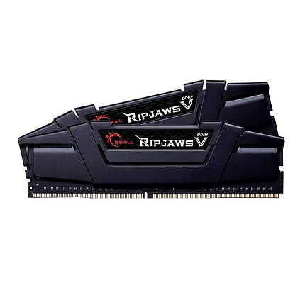

Inner

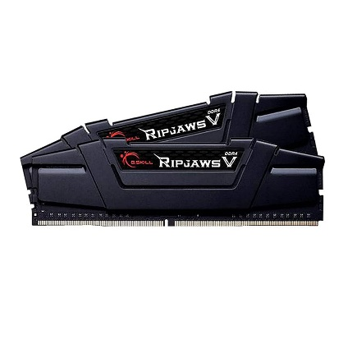

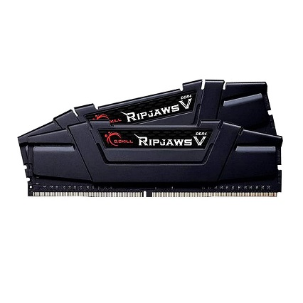

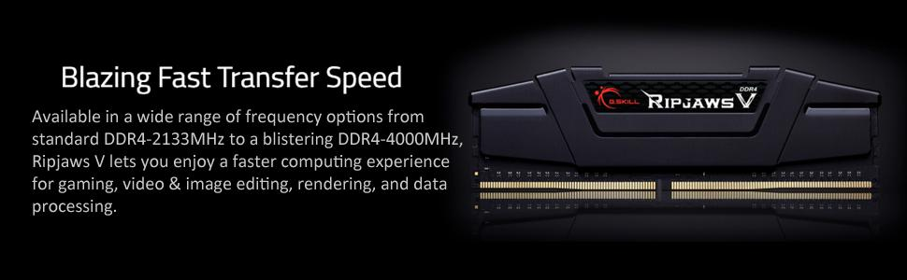

G.Skill Ripjaws V 16GB (2x8GB) DDR4-3200MHz CL16-18-18-38 1.35V Desktop Memory RAM - F4-3200C16D-16GVKB, Black

-61% ₹7,500.00₹7,500.00

M.R.P.: ₹19,000.00₹19,000.00

### Product details

|  |  |
| --- | --- |
| **Brand** | G.Skill |
| **Computer Memory Size** | 16 GB |
| **RAM Memory Technology** | DDR4 |
| **Memory Speed** | 3200 MHz |
| **Compatible Devices** | Desktop |
| **Voltage** | 1.2 Volts |

* Ripjaws V Series DDR4 16GB RAM
* 16GB (2x8GB) Dual Channel Kit
* SPD Speed 3200MHz SPD Voltage 1.35v
* Tested Speed 3200MHz Tested Latency CL16-18-18-38
* Intel XMP 2.0 (Extreme Memory Profile) Ready